Experiment No. 9

Title
Understanding Different Types of Shells and Writing A Shell Script

Aim
The problem is to identify different types of shells available in Linux, understand their characteristics, and write and execute a simple shell script using Bash, including the use of variables.

Theory

Shell In Linux
A shell is a command-line interpreter that processes user commands and communicates with the kernel. It allows users to execute commands, manage files, and write scripts for automation.
Types Of Shells
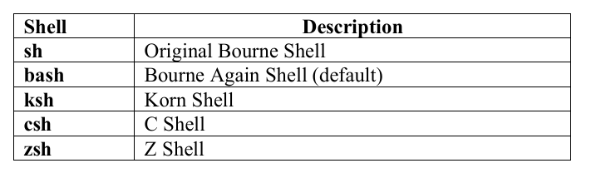

Bash Shell
Bash is an enhanced version of sh that supports:
- Command history
- Job control
- Scripting with variables and control structures

Shell Scripts

A shell script is a file containing a sequence of commands executed by the shell. It typically starts with a shebang (#!/bin/bash) that specifies the interpreter.

COMMANDS USED-

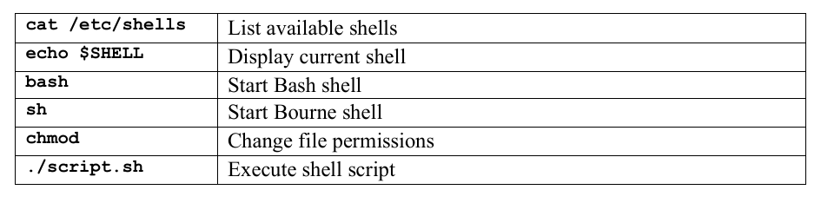

Procedure / Steps

Identifying Different Shells

Open the terminal.

List available shells:

cat /etc/shells

Check the current shell:

echo $SHELL

Switching Between Shells

Switch to Bourne shell:

sh

Return to Bash:

Exit

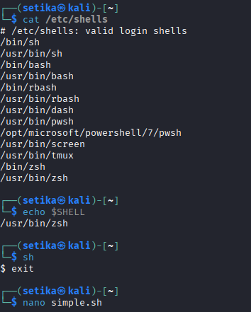

Writing a Simple Bash Script

Create a new script file:

nano simple.sh

Enter the following script:

#!/bin/bash

echo "Welcome to Linux Shell Scripting"

name="Student"

echo "Hello $name" Save and exit the editor.

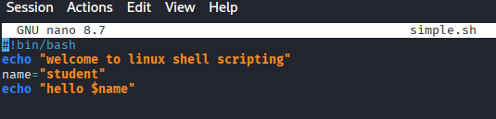

Executing the Script

Provide execute permission:

chmod +x simple.sh

Run the script:

./simple.sh

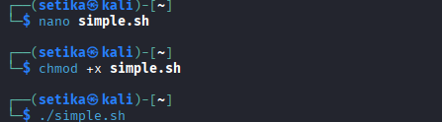

Outcomes
- List of available shells displayed.
- Current shell identified.
- Simple Bash script executed successfully.
- Output displays variable values correctly.

Result
- Different types of Linux shells were identified and a simple Bash shell script using variables was successfully written and executed.

